Capstone Project - II Report on

**Vision Vault Check In**

at

**U. V. Patel College of Engineering**



## Internal Guide : Prepared By:

Prof. Ketan J Sarvarkar Mr. Yash Barvaliya (21012531002)

Mr. Fenil Patel(21012531006) Mr. Vivek Patel (21012531015) Ms. Ritika Lal (21012531021)

## B.Tech Semester VI

**(Computer Engineering - Artificial Intelligence)**

March 2024

Submitted to,

Department of Computer Engineering - Artificial Intelligence

U.V. Patel College of Engineering Ganpat University, Ganpat Vidyanagar- 384 012

**U.V. PATEL COLLEGE OF**

**ENGINEERING**



**09/12/23**

**CERTIFICATE**

**TO WHOM SO EVER IT MAY CONCERN**

This is to certify that Mr. **Yash Barvaliya** student of **B.Tech. Semester VI (Computer Engineering - Artificial Intelligence)** has completed his full semester Capstone Project work titled “**Vision Vault Check In”** satisfactorily in partial fulfillment of the requirement of Bachelor of Technology degree of Computer Engineering - Artificial Intelligence of Ganpat University, Ganpat Vidyanagar, Mehsana in the year 2023-2024.

**U.V. PATEL COLLEGE OF**

**ENGINEERING**



**09/12/23**

**CERTIFICATE**

**TO WHOM SO EVER IT MAY CONCERN**

This is to certify that Mr. **Fenil Patel** student of **B.Tech. Semester VI (Computer Engineering - Artificial Intelligence)** has completed his full semester Capstone Project work titled “**Vision Vault Check In”** satisfactorily in partial fulfillment of the requirement of Bachelor of Technology degree of Computer Engineering - Artificial Intelligence of Ganpat University, Ganpat Vidyanagar, Mehsana in the year 2023-2024.

**U.V. PATEL COLLEGE OF**

**ENGINEERING**



**09/12/23**

**CERTIFICATE**

**TO WHOM SO EVER IT MAY CONCERN**

This is to certify that Mr. **Vivek Patel** student of **B.Tech. Semester VI (Computer Engineering - Artificial Intelligence)** has completed his full semester Capstone Project work titled “**Vision Vault Check In”** satisfactorily in partial fulfillment of the requirement of Bachelor of Technology degree of Computer Engineering - Artificial Intelligence of Ganpat University, Ganpat Vidyanagar, Mehsana in the year 2023-2024.

**U.V. PATEL COLLEGE OF**

**ENGINEERING**



**09/12/23**

**CERTIFICATE**

**TO WHOM SO EVER IT MAY CONCERN**

This is to certify that Ms. **Ritika Lal** student of **B.Tech. Semester VI (Computer Engineering - Artificial Intelligence)** has completed her full semester Capstone Project work titled “**Vision Vault Check In”** satisfactorily in partial fulfillment of the requirement of Bachelor of Technology degree of Computer Engineering - Artificial Intelligence of Ganpat University, Ganpat Vidyanagar, Mehsana in the year 2023-2024.

I

# ACKNOWLEDGEMENT

First and foremost, We would like to thank our guide, **Prof. Ketan Sarvarkar** Sir, for their invaluable guidance, encouragement, and unwavering support throughout the entire duration of this project. Their expertise and insights were instrumental in shaping the direction of this report, and we are truly grateful for their mentorship.

### Thank you, Sir Fenil,Ritika,Vivek,Yash

II

# ABSTRACT

This project, titled "Vision Vault Check-In", introduces a cutting-edge system that leverages face detection and recognition for secure and efficient check-in processes. The system caters to a wide range of applications, offering a user-friendly alternative to traditional methods.Employing advanced algorithms and machine learning models, Vision Vault Check offers a comprehensive solution for real-time face detection and recognition. By harnessing the power of deep learning, the system can swiftly and accurately identify individuals within a specified database, facilitating secure access control and streamlined authentication procedures.This documentation delves into the development of the Vision Vault Check-In system. It explores the selection and implementation of robust face detection and recognition algorithms, along with a detailed explanation of the system architecture. The document further discusses comprehensive testing procedures employed to ensure the system's accuracy, performance, and security.The Vision Vault Check-In system not only demonstrates the potential of facial recognition technology but also paves the way for further development and integration into diverse applications. This project signifies a step forward in creating a more streamlinedand secure check-in experience across various domains.

III

**Table of Contents**

#### Acknowledgement I

**Abstract** II

#### Introduction 1

* 1. Project Overview 1
  2. Background… 1
  3. Purpose 1
     1. Problem Statement 1
     2. Problem Aim 1
     3. Problem Objectives 1
  4. Project Scope 2
  5. Impact, Significance and Contributions 4

#### Literature Review 6

* 1. Kintrans 6
  2. SignAll 6
  3. MotionSavvy… 7
  4. Five.ai 7
  5. Sestek… 8

#### Feasibility Analysis 9

* 1. Technical feasibility… 9
  2. Time schedule feasibility… 9
  3. Operational feasibility… 9
  4. Implementation feasibility… 9
  5. Economic feasibility 10

#### Software requirement specifications (SRS). 11

* 1. Software Requirements 11
  2. Hardware Requirements 11

#### Diagrams 13

* 1. Class Diagrams 13
  2. Activity Diagrams 14
  3. Use-Case Diagram 15

#### Prototypes 16

* 1. Landing Page 16
  2. Home Page 17

IV

* 1. Audio to Sign Converter… 18
  2. Sign to Audio Converter… 19
  3. Sign Language Dictionary… 20

#### Implementation 21

* 1. Understanding the Foundation… 21
  2. Data Collection and preprocess 25
  3. Data Preprocess 27
  4. Gesture Detection… 29
  5. Gesture Recognition Using YOLOv5… 31
  6. Text to Speech Model Creation… 35
  7. Speech to Sign Model 37
  8. Mobile App Development 39
  9. Security and Privacy Measures 40
  10. Scalability and Performance Optimization… 41
  11. Documentation and Ongoing Maintenance 43
  12. Final Testing and User Feedback… 43
  13. Deployment Strategies 43

#### Testing 45

* 1. Introduction to Sign Language Testing 45
  2. Testing Strategies 45
  3. Importance of Testing 45
  4. Unit Testing 45
  5. Integration Testing 47
  6. User Testing 48
  7. Performance Testing 48
  8. Usability Testing 49
  9. Scalability Testing 49

#### Conclusion and Future Work 51

* 1. Conclusion… 51
  2. Key Achievements 51
  3. Challenges Overcome 51
  4. Future Work 52

#### References 53

V

**List of Figures**

**Fig 1.1 : System Architecture** **1**

**Fig 5.1 : Class Diagram…** **13**

**Fig 5.2 : Activity Diagram…** **14**

**Fig 5.3 : Use-Case Diagram…** **15**

**Fig 6.1 : Landing Page** **16**

**Fig 6.2 : Home Page** **17**

**Fig 6.3 : Audio to Sign Converter** **18**

**Fig 6.4 : Sign to Audio Converter** **19**

**Fig 6.5 : Sign Language Dictionary** **20**

**Fig 7.1 : Training/Testing** **22**

**Fig 7.2 : Methodology…** **22**

**Fig 7.3 : CNN Architecture** **23**

**Fig 7.4 : YOLO Algorithm…** **23**

**Fig 7.5: Model Optimization** **24**

**Fig 7.6 : Sign to Word Conversion** **25**

**Fig 7.7 : Sign Data…** **26**

**Fig 7.8 : Annotation of Data…** **28**

**Fig 7.9 : Preparation** **30**

**Fig 7.10 : Gesture Labeling…** **31**

**Fig 7.11 : Gesture Recognition** **32**

**Fig 7.12 : Accuracy…** **33**

**Fig 7.13 : Loss** **34**

**Fig 7.14 : Text to Speech** **35**

**Fig 7.15 : Speech to Text** **36**

**Fig 8.1 : Unit Test Correlation** **46**

**Fig 8.2 : Training and Testing** **47**

# INTRODUCTION

### Project Overview

The Vision Vault Check In project, led by a team of four engineering students, is an innovative project that focuses on advancing face detection and recognition systems using state-of-the-art computer vision techniques. In response to the increasing demand for secure and efficient authentication methods, Vision Vault Check offers a comprehensive solution that combines deep learning algorithms with real-time processing capabilities. Vision Vault Check-In showcases the potential of facial recognition for streamlined check-in experiences. This project lays the groundwork for further development and integration across diverse domains.

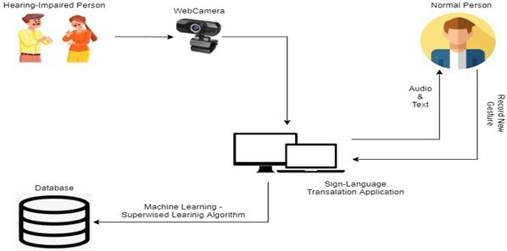

**Fig 1.1 : System Architecture**

### Background

Traditional check-in procedures often rely on manual methods like ID verification or badge swiping, which can be time-consuming and prone to human error. In today's fast-paced environment, there's a growing demand for secure and efficient alternatives. However, despite their potential benefits, existing face detection and recognition systems still face several challenges. These include issues related to accuracy, scalability, robustness in varying environmental conditions, and concerns regarding user privacy and data security.

### Purpose

#### Problem Statement

Current check-in processes often suffer from many limitations such as,

* Time-consuming Procedures: Manual verification of IDs or badges can lead to long wait times.
* Human Error: Manual data entry and verification are susceptible to errors.
* Lack of Scalability: Manual check-in systems struggle to handle large volumes efficiently.

#### ProblemAim

The aim of the Vision Vault Check project is to develop an advanced face detection and recognition system that overcomes the limitations of existing solutions, providing a reliable, scalable, and secure authentication mechanism suitable for various applications and environments.

#### Problem Objectives

* Improve Detection Accuracy: Enhance the accuracy of face detection algorithms to accurately identify individuals even in challenging conditions such as low lighting, varying angles, and partial occlusions.
* Enhance Recognition Accuracy: Improve the recognition accuracy of identified faces by implementing advanced deep learning algorithms capable of distinguishing between individuals with high precision.
* Optimize Speed and Efficiency: Develop efficient processing techniques to ensure real-time performance, allowing for swift identification and recognition of individuals without compromising accuracy.
* Ensure Scalability: Design the system architecture to efficiently handle large databases of individuals, ensuring scalability without sacrificing performance or accuracy.

### Project Scope

The scope of the Vision Vault Check In project encompasses the following key aspects:

#### Face Detection Module

* Develop an advanced face detection module capable of accurately detecting faces in images or video streams, even under challenging conditions such as varying lighting, angles, and occlusions.

#### Face Recognition Module

* Implement a robust face recognition module utilizing deep learning algorithms to accurately identify and verify individuals based on their facial features, ensuring high precision and reliability.

#### Real Time Processing

* Ensure real-time processing capabilities to enable swift identification and recognition of individuals without significant latency, facilitating seamless authentication processes in time-sensitive applications.

#### Scalability

* Design the system architecture to handle large databases of individuals efficiently, allowing for seamless scalability to accommodate growing datasets and diverse applications.

#### Robustness

* Implement mechanisms to enhance the robustness of the system against environmental factors, variations in facial appearance, and potential adversarial attacks, ensuring consistent performance across different scenarios.

#### Privacy and Security

* Incorporate privacy-preserving measures to protect sensitive user data and ensure compliance with privacy regulations. Implement robust security measures to safeguard the integrity of the system and prevent unauthorized access or tampering of data.

#### Usability

* Prioritize user-friendliness and practical usability by designing intuitive interfaces and seamless integration with existing workflows and applications, ensuring a positive user experience.

#### Testing and Validation

* Conduct thorough testing and validation procedures to assess the performance, accuracy, and reliability of the Vision Vault Check system across diverse scenarios and environments, ensuring its effectiveness and practical viability.

#### Documentation and Deployment

* Prepare comprehensive documentation detailing the system architecture, implementation details, usage instructions, and best practices. Facilitate the deployment of the Vision Vault Check system in real-world settings, providing support and guidance for integration and maintenance.

#### Future Enhancements

* Identify opportunities for future enhancements and improvements based on user feedback, technological advancements, and evolving security requirements, ensuring the continuous evolution and refinement of the Vision Vault Check system.

#### Project Timeline

* + - * The project scope will be executed within the allotted timeframe of the capstone course, with the possibility of future enhancements post-graduation.

#### Collaboration

* + - * The project will leverage the collective expertise and contributions of all team members, with clear roles and responsibilities outlined.

This project scope outlines the key components and objectives of the Vision Vault Check system, providing a clear understanding of the project's focus and deliverables.

### Impact, Significance, and Contributions

#### Enhanced Security

* By providing a robust and reliable authentication mechanism based on face detection and recognition technology, Vision Vault Check significantly enhances security measures in applications such as access control, surveillance systems, and identity verification processes. This contributes to mitigating security risks and preventing unauthorized access to sensitive areas or information.

#### Streamlined Authentication Process

* Vision Vault Check offers a seamless and efficient authentication process, enabling quick and accurate identification of individuals without the need for cumbersome passwords or PINs. This streamlines authentication workflows in various settings, reducing administrative burdens and enhancing user convenience.

#### Improved User Experience

* The implementation of Vision Vault Check results in an improved user experience by offering a frictionless authentication process that is intuitive, efficient, and non-intrusive. This enhances user satisfaction and productivity, leading to positive outcomes in both consumer-facing and enterprise applications.

#### Enhanced Operational Efficiency

* With its real-time processing capabilities and scalability, Vision Vault Check contributes to enhanced operational efficiency in organizations by enabling swift and accurate identification of individuals across diverse environments. This optimizes resource allocation, minimizes delays, and improves overall workflow efficiency.

#### Facilitation of Innovation

* The development of Vision Vault Check contributes to advancing the field of computer vision and biometric authentication technologies, paving the way for further innovation and research in areas such as deep learning algorithms, image processing techniques, and privacy-preserving mechanisms. This fosters a culture of innovation and drives progress in related fields.

#### Compliance with Regulatory Standards

* Vision Vault Check prioritizes user privacy and data security, ensuring compliance with contemporary regulatory standards such as GDPR, CCPA, and HIPAA. By implementing stringent privacy-preserving measures and robust security protocols, the project contributes to building trust among users and stakeholders.

#### Knowledge Dissemination and Collaboration

* Through documentation, publications, and knowledge sharing, the Vision Vault Check project contributes to disseminating valuable insights, methodologies, and best practices in the fields of computer vision, biometrics, and cybersecurity. This fosters collaboration among researchers, practitioners, and industry stakeholders, driving collective efforts towards addressing common challenges and advancing the state-of-the-art.

#### 

#### Empowering Engineering Students

* + - * The project provides engineering students with a hands-on experience in developing a practical and socially impactful solution. It equips them with valuable technical skills and a sense of social responsibility.

### Organization of Project Report

#### Literature Survey

Includes survey of few similar project built by other persons and concluded what are the features and technologies they have used.

#### Functional and non-functional requirements

In this chapter, we studied all possible functionalities and non-functionalities of our model.

#### Diagrams

Diagrams refers the working flows, classes, sequences, and states of our model.

#### Prototype

Chapter belongs to looks and appearance of model that how it will present infront of users.

#### Conclusion and Future works

Summary of the project is included in this chapter.

#### References

Provided some reference links of projects to refer how the system will be

# LITERATURE REVIEW

Certainly, let's provide more in-depth information about each of the companies and organizations involved in this technology:

### Sensetime

#### Overview

SenseTime [1] is a pioneering artificial intelligence (AI) company that specializes in computer vision and deep learning technologies, with a primary focus on face detection and recognition. Founded in 2014 by a group of researchers from the Chinese University of Hong Kong, SenseTime[1] has rapidly grown to become one of the world's leading AI companies, boasting a wide range of applications across various industries.

#### Technology

SenseTime's[1] core expertise lies in developing advanced algorithms and deep learning models for face detection, recognition, and analysis. Leveraging state-of-the-art techniques such as convolutional neural networks (CNNs), recurrent neural networks (RNNs), and generative adversarial networks (GANs), SenseTime[1] has achieved remarkable accuracy and efficiency in identifying and analyzing faces in images and videos.

#### Applications

#### SenseTime's[1] face detection and recognition technology have applications in healthcare, including patient identification, medical imaging analysis, and telemedicine. It enables healthcare providers to accurately identify patients, access medical records securely, and analyze medical images for diagnosis and treatment planning.

### Dahua

#### Overview

Dahua Technology [2]is a leading provider of video surveillance and security solutions, specializing in the development and manufacturing of innovative products and technologies for various industries. Established in 2001, Dahua[2] has grown to become one of the largest suppliers of video surveillance equipment globally, with a strong focus on research and development

#### Technology

Dahua Technology[2] is known for its expertise in video surveillance technologies, including advanced image processing, video analytics, and artificial intelligence. The company develops cutting-edge solutions for various applications, ranging from traditional surveillance cameras and recorders to more advanced systems incorporating AI-powered features such as facial recognition, object detection, and behavior analysis.

#### Applications

Dahua's[2] advanced video surveillance systems are deployed in public spaces, commercial facilities, and critical infrastructure to monitor and safeguard assets, deterring unauthorized activities and enhancing overall security.

### Microsoft Azure Cognitive Services

#### Overview

In the realm of face detection and recognition, Microsoft [3]has made significant contributions through its research and development efforts, particularly with its Azure Cognitive Services platform.

#### Technology

Microsoft's Azure Cognitive Services platform[3] offers a suite of powerful APIs and SDKs, including the Face API, which provides robust capabilities for face detection, identification, verification, and emotion recognition. Leveraging state-of-the-art deep learning algorithms, Microsoft's Face API delivers accurate and efficient face detection and recognition functionalities, enabling seamless integration into applications and systems.

#### Applications

#### Microsoft's Face API[3] is utilized in a wide range of applications and solutions across various industries. From security surveillance systems to personalized user experiences, the Face API empowers developers to build innovative applications that leverage facial recognition technology for authentication, access control, sentiment analysis, and more.

### Megvii(Face++)

#### Overview

Megvii [4]Technology, commonly known as Face++[4], is a leading Chinese artificial intelligence company specializing in computer vision and facial recognition technologies. Founded in 2011, Megvii has emerged as a pioneer in the field, offering advanced solutions for face detection, recognition, and analysis

#### Technology

#### Megvii's [4] expertise lies in developing cutting-edge algorithms and deep learning models for facial recognition tasks. The company's flagship product, Face++, employs state-of-the-art convolutional neural networks (CNNs) and facial feature extraction techniques to achieve high accuracy and efficiency in face detection and recognition.

#### Applications

Face++[4] offers a comprehensive suite of products and solutions tailored to various industries and applications. Its portfolio includes face detection APIs, face recognition SDKs, and customized solutions for security surveillance, access control, retail analytics, and more. Face++'s[4] solutions are widely adopted by businesses, government agencies, and developers worldwide.

# FEASIBILITY ANALYSIS

### Technical feasibility

#### Hardware and Software Requirements

The hardware requirements for a face detection and recognition system include sufficient processing power (CPUs or GPUs), memory (RAM), storage space, high-quality cameras, and a reliable network infrastructure. On the software side, it requires an operating system, development frameworks/libraries (e.g., OpenCV, TensorFlow), face detection/recognition software (e.g., Microsoft Face API), a database management system, middleware/integration components, user interface, and security protocols/software.

#### Technology Expertise

The technological expertise required for a face detection and recognition system encompasses proficiency in computer vision, image processing, and deep learning techniques. Developers should be skilled in utilizing frameworks and libraries such as OpenCV, TensorFlow, or PyTorch for implementing advanced algorithms like convolutional neural networks (CNNs) and facial feature extraction methods. Additionally, expertise in optimizing algorithms for real-time processing, handling large datasets, and ensuring scalability is crucial.

#### Data Availability

Data availability plays a crucial role in the development of face detection and recognition systems, enabling the training of accurate and robust machine learning models. By leveraging diverse datasets responsibly and implementing robust data security measures, developers can build systems that deliver reliable performance while respecting user privacy and regulatory requirements.

### Time schedule feasibility

#### Project Timeline

Create a detailed project timeline with milestones and deadlines. Ensure that the project can be completed within the allotted time, considering factors like development, testing, and documentation phases.

#### Resource Allocation

Assess the availability of team members and other resources required to meet the project's timeline. Ensure that workloads are manageable and realistic.

### Operational feasibility

#### User Needs and Acceptance

#### User acceptance of a face detection and recognition system hinges on meeting their needs for usability, accuracy, privacy, and convenience. Users seek intuitive interfaces for swift and reliable recognition, while prioritizing privacy safeguards and transparent data handling practices. Features enhancing convenience and functionality, coupled with responsive support and continuous improvement, foster positive perceptions and drive adoption. Ultimately, aligning the system with user preferences and addressing concerns ensures widespread acceptance and trust.

#### User Training

User training is essential for ensuring effective utilization and understanding of a face detection and recognition system. Training sessions should focus on familiarizing users with system functionalities, including how to initiate facial recognition processes, interpret results, and troubleshoot common issues

### Implementation feasibility

#### Development Resources

Assess the availability of development resources, including developers, designers, and testers. Determine if there are any resource constraints or dependencies that might impact project execution.

#### Infrastructure and Hosting

Ensure that there is a suitable infrastructure or hosting environment for deploying the system. Consider scalability and reliability requirements.

### Economic feasibility

#### Cost Analysis

Estimate the project's overall cost, including development, hardware, software, training, and ongoing maintenance. Compare this with the available budget to ensure that the project remains financially viable.

#### Return on Investment (ROI)

Assess the potential return on investment, considering factors such as increased accessibility for the deaf community, educational benefits, and possible revenue streams if the system is commercialized.

## Software requirement specifications (SRS)

### Software Requirements

#### Operating System

* **Development**: Windows, macOS, or Linux (based on the developers' preferences)
  + **Deployment Server**: Linux (recommended for server hosting due to stability and cost- effectiveness)

#### Development Tools and Frameworks

* **Programming Languages**: Python (for machine learning and backend development), JavaScript/HTML/CSS (for web development)
  + **Python Libraries**: TensorFlow or PyTorch (for machine learning), OpenCV (for computer vision), NLTK or spaCy (for NLP)
* **Web Framework**: Django or Flask (for backend), React or Angular (for frontend)
* **Database Management System**: PostgreSQL or MySQL (for data storage)
* **Web Server**: Nginx or Apache (for serving web applications)

#### Version Control

* Git and a platform like GitHub, GitLab, or Bitbucket for version control and collaboration.

#### Integrated Development Environment (IDE)

* A code editor or IDE of choice for Python and web development, such as Visual Studio Code, PyCharm, or Sublime Text.

#### Development and Testing Tools

* **Testing Frameworks**: pytest, Selenium (for automated testing)
* **Virtual Environment**: Virtualenv or Conda for managing Python dependencies
* **Dependency Management**: pip for Python package management
  + **Continuous Integration/Continuous Deployment (CI/CD) Tools**: Jenkins, Travis CI, CircleCI, or GitLab CI/CD for automated testing and deployment.

### Hardware Requirements

#### Development Machine

* A modern computer or laptop with a multi-core CPU (Intel i5 or above, AMD Ryzen equivalent recommended) and at least 8 GB of RAM.
* Sufficient storage space for development tools and datasets (minimum 256 GB SSD recommended).

#### Server Hosting

* If deploying the project to a cloud server, consider cloud providers like Amazon Web Services (AWS), Google Cloud Platform (GCP), or Microsoft Azure.
* The server hardware specifications will depend on the expected traffic and resource requirements.

#### Web Server Hardware

* For serving the web application, ensure the server has adequate CPU, RAM, and storage resources to handle incoming requests efficiently.

#### Database Server Hardware

* If deploying a separate database server, ensure it meets the requirements of the chosen DBMS (e.g., PostgreSQL or MySQL).

#### Machine Learning Hardware (Optional)

* For training machine learning models, consider using a machine with a high-end GPU (NVIDIA GeForce RTX or higher) or access to cloud-based GPU instances for faster training times.

#### Web Camera (for testing and potentially for real-time sign language translation)

* A compatible webcam for capturing sign language gestures, if needed for specific project features.

## Diagrams

### Class Diagrams

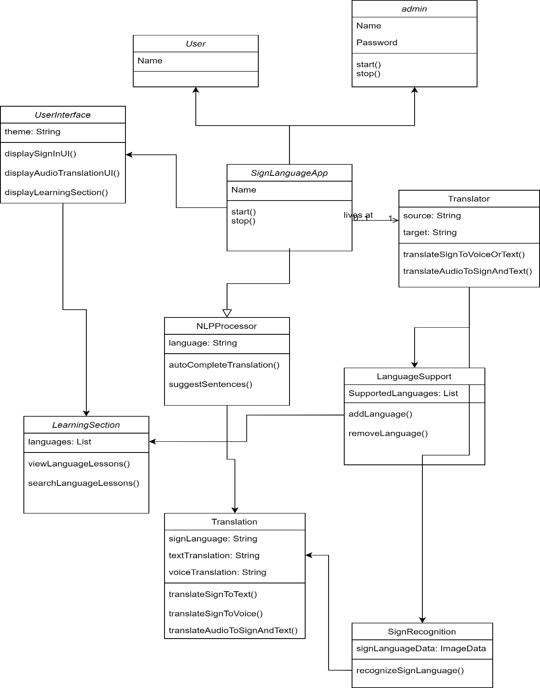

#### Fig 5.1 : Class Diagram

SignLanguageApp class: Represents the main application with attributes and methods for managing the entire system.

Translator class: Manages sign to voice or text translation and vice versa. AudioConverter class: Handles the conversion of audio to sign and text. NLPProcessor class: Integrates NLP for auto-completion and suggested sentences.

LanguageSupport class: Manages support for multiple sign languages. UserInterface class: Handles the mobile app's user interface.

LearningSection class: Represents the optional learning section with subsections for different sign languages.

### Activity Diagrams

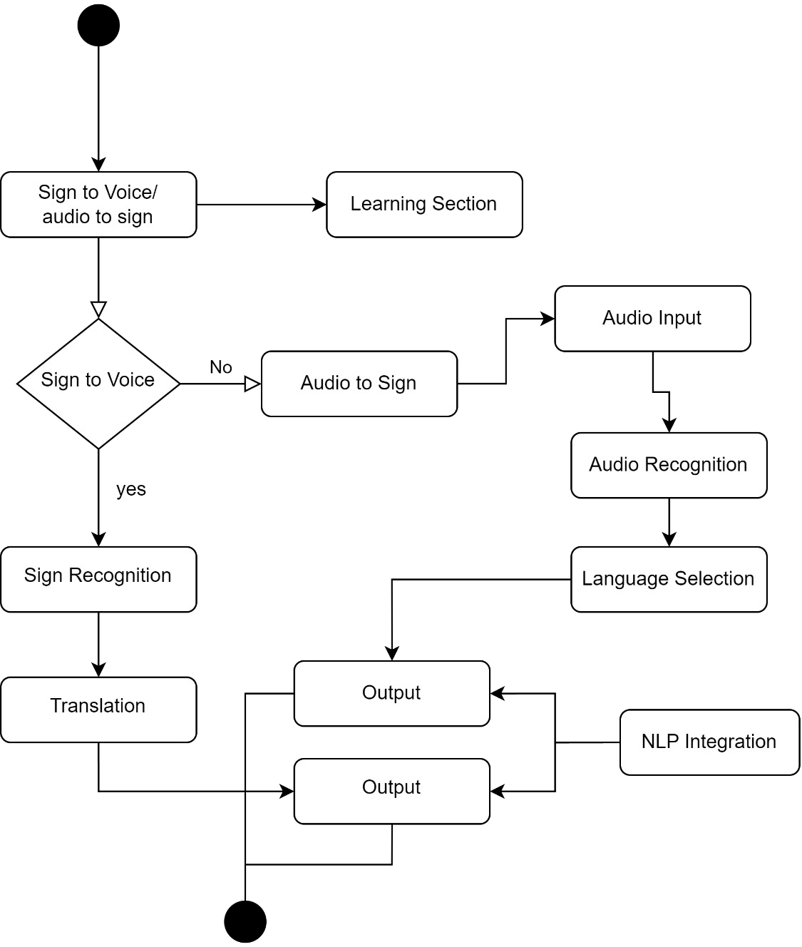

#### Fig 5.2 : Activity Diagram

* Start: The user opens the app.
* Sign to Voice/Text Activity: User selects "Sign to Voice or Text" translation.
* Sign Recognition: The app captures and recognizes sign language gestures.
* Translation: Converts sign language to voice or text.
* Output: Displays the translated text or voice.
* Audio to Sign/Text Activity: User selects "Audio to Sign or Text" translation.
* Audio Input: The user records or inputs spoken language.
* Audio Recognition: The app analyzes and converts audio to sign language and text.
* Output: Displays the translated sign language and text.

NLP Integration: When auto-completion is enabled, NLP suggests complete sentences. Language Selection: User selects a specific sign language.

Learning Section: If chosen, the user can access the learning section.

### Use-Case Diagram

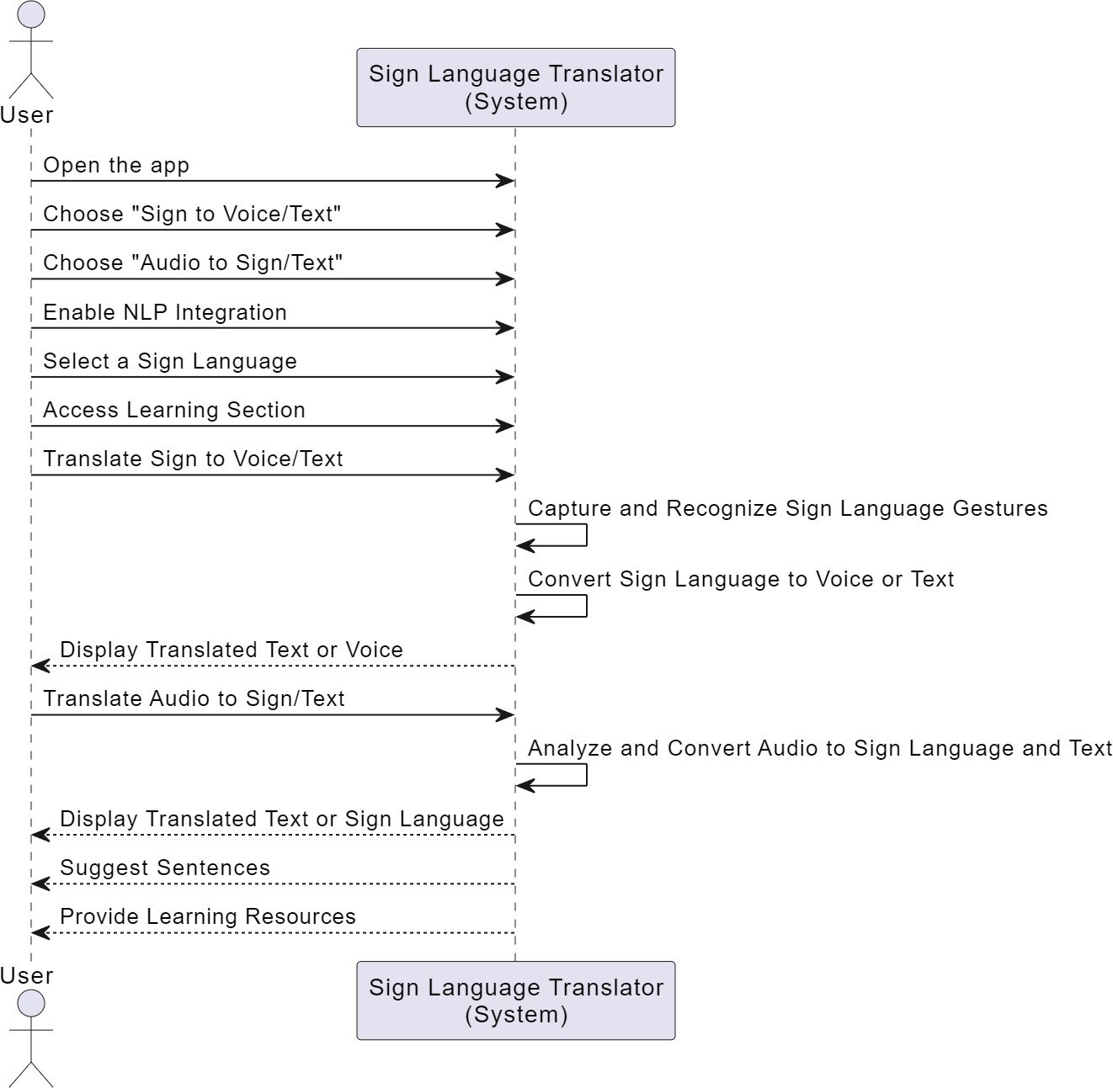

#### Fig 5.3 : Use-Case Diagram

The "User" (Actor) represents individuals who interact with the Sign Language Translator app.

The "Use Cases" under the "User" actor represent actions or functionalities that users can perform.

"System" represents the Sign Language Translator system itself.

The "Use Cases" under the "System" actor represent the app's functionalities or services.

## Prototypes



**Fig 6.1 Landing Page [6]**

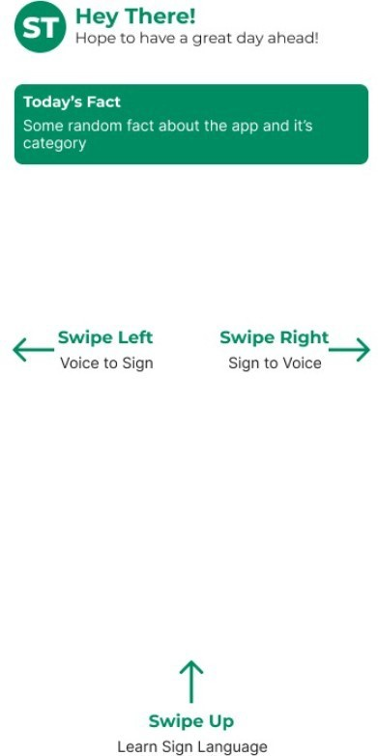

**Fig 6.2 Home Page [6]**

**Fig 6.3 Audio to Sign Converter [6]**

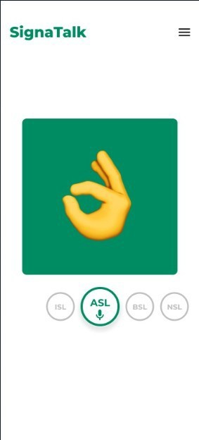

**Fig 6.4 Sign to Audio converter [6]**

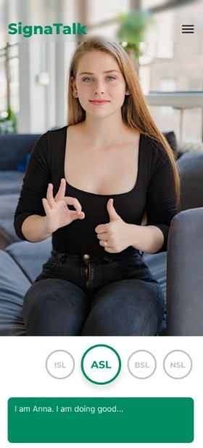

**Fig 6.5 Sign Language Dictionary [6]**

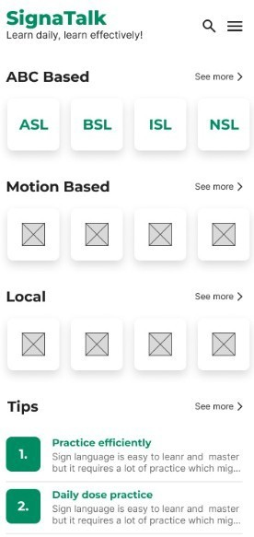

## Implementation

### Understanding the Foundation

#### Tech Stack

The technological foundation of the Sign Language Translator project is its cornerstone. A meticulous selection of the technology stack was vital to ensure the project's success. The chosen stack reflects a blend of robustness, flexibility, and scalability, catering to the project's diverse requirements.

At the heart of our tech stack is Python, a versatile and powerful programming language. Python’s extensive libraries and frameworks provide a solid foundation for developing machine learning and natural language processing components. TensorFlow, an open-source machine learning framework, empowers our deep learning models, ensuring accurate gesture recognition. Its flexibility allows us to experiment with various neural network architectures.

In tandem with TensorFlow, OpenCV, a computer vision library, forms the visual perception backbone of the project. OpenCV's rich functionalities facilitate gesture analysis and key point detection. Additionally, scikit-learn, a machine learning library, aids in data preprocessing and classification tasks.

For real-time user interaction, we turned to Flutter, Google’s UI toolkit for building natively compiled applications for mobile, web, and desktop from a single codebase. Flutter's cross- platform capabilities enable seamless user experiences across different devices and platforms, making our application accessible to a wider audience.

Database management is crucial for storing and retrieving data efficiently. PostgreSQL, a powerful open-source relational database system, ensures robust data storage, while Redis, an in-memory data structure store, enhances data processing speed. These technologies together form a reliable data management layer.

#### Sign Language Linguistics Research

Sign language is a rich and complex form of communication, transcending mere gestures. To bridge the communication gap effectively, understanding the linguistic nuances of sign languages is paramount. Collaboration with linguists and sign language experts was instrumental in delving deep into the grammar, syntax, and regional variations of various sign languages.

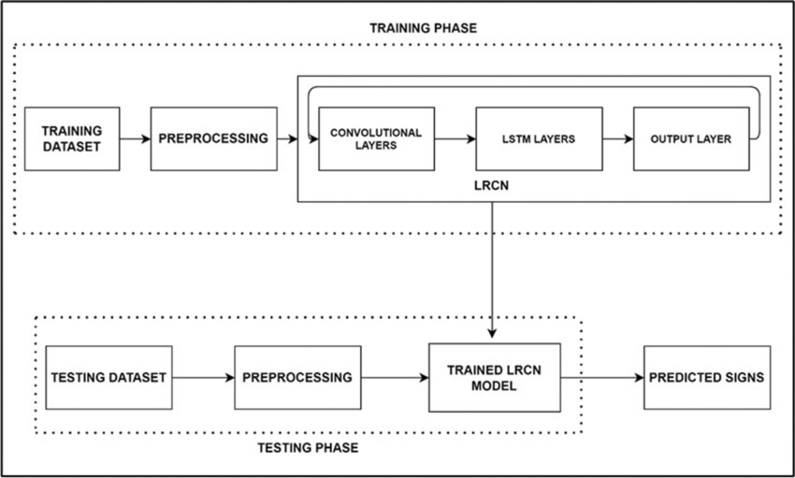

#### Fig 7.1 Training/Testing

In our research, we explored the intricacies of American Sign Language (ASL), British Sign Language (BSL), International Sign Language (ISL), as well as numerous local and global sign languages. We analyzed the grammatical structures unique to each language, dissecting facial expressions, hand movements, and body postures that convey meaning. This profound linguistic understanding formed the basis for our gesture recognition models.

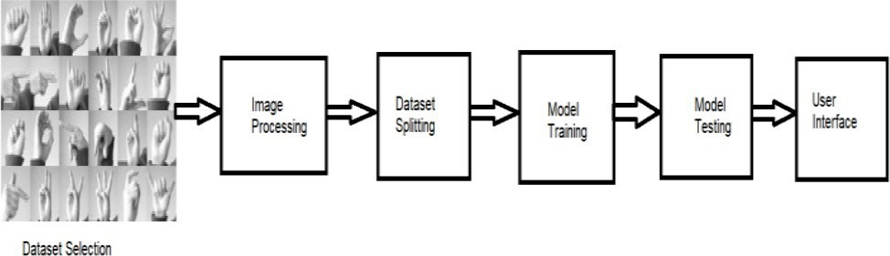

#### Fig-7.2 Methodology

First we have selected the sign language dataset and from that dataset we have fetched the images. Using image processing we have converted those images into pixels. We did this image processing for CNN. Then in dataset splitting we have divided this dataset for training and testing purpose. Using this training and testing samples we have trained and tested our model. At last we have created the user interface for real time detection. If Images/features in the training dataset are tilted or rotated then CNN have difficulty in classifying those images

#### Deep Dive into YOLOv5

Gesture detection forms the core of the Sign Language Translator project. The choice of YOLOv5 (You Only Look Once version 5) as our object detection framework was pivotal. YOLOv5 stands out for its real-time capabilities, striking a balance between detection accuracy and computational efficiency. [7]

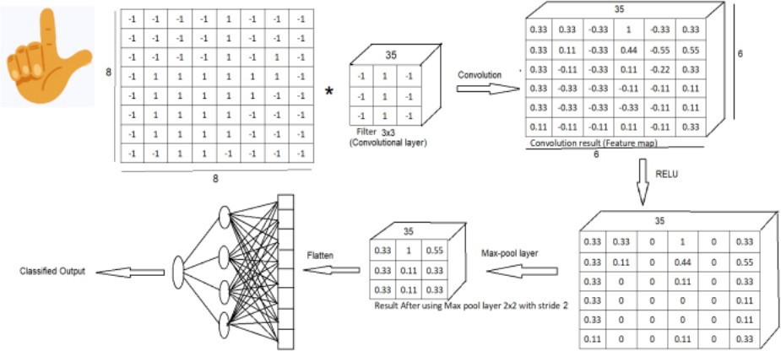

**Fig-7.3 CNN Architecture**

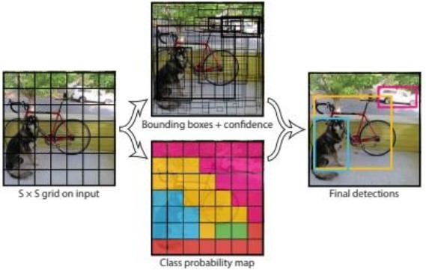In our deep dive into YOLOv5, we comprehensively explored its architecture and inner workings. YOLOv5’s unique approach of dividing an image into a grid and predicting bounding boxes and class probabilities for each grid cell ensures rapid and accurate detection. Understanding anchor boxes, which dictate the size and aspect ratio of predicted boxes, allowed us to fine-tune our model for different sign language gestures.

#### Fig-7.4 YOLO Algorithm

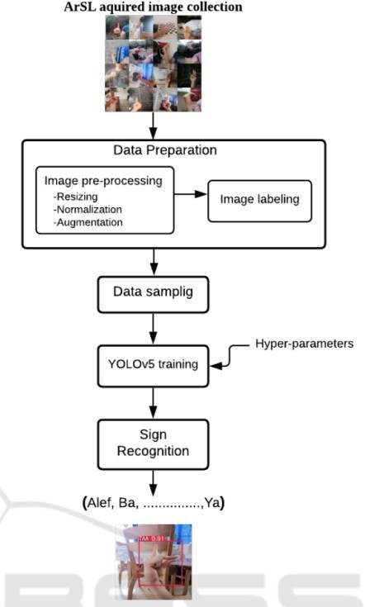

**Fig 7.5 : Model Optimization**

Model optimization was a key focus, where we experimented with various configurations, balancing the number of layers, filter sizes, and anchor box settings. This process, while iterative, was crucial in achieving real-time gesture recognition, a fundamental requirement for seamless communication. [7]

#### Understanding LSTM for Sentence Completion

The Sign Language Translator project not only recognizes individual gestures but also comprehends the context in which they occur. Long Short-Term Memory (LSTM), a type of recurrent neural network (RNN), emerged as the go-to solution for understanding and predicting sequential data, ensuring fluent and contextually relevant sentence completions.

In Understanding LSTM, we delved into its architecture, focusing on memory cells, input gates, and output gates. LSTM’s ability to capture long-term dependencies in data was harnessed to predict sign language sentences accurately. Training our LSTM model involved exposing it to vast datasets of sign language expressions, allowing it to grasp the subtleties of sign language grammar and syntax.

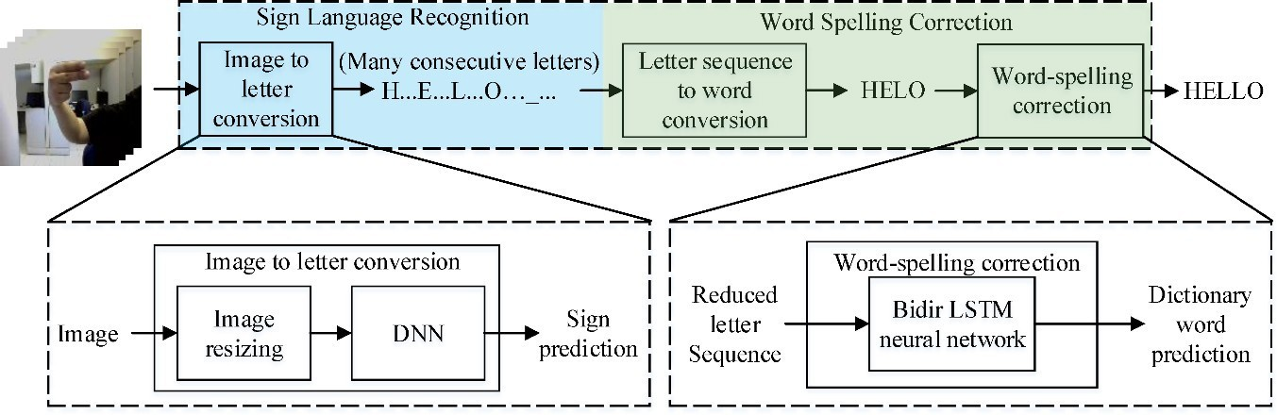

#### Fig-7.6 Sign to word conversion

To enhance LSTM’s predictive capabilities, we fine-tuned hyperparameters such as the number of LSTM layers, hidden units, and learning rates. Regularization techniques were employed to prevent overfitting, ensuring that the model generalized well to unseen sign language expressions.

### Data Collection and preprocess

#### Data Sources

The foundation of the Sign Language Translator project lies in the data collected for training and development. Our data sources encompass a diverse range of sign languages, audio recordings, and text data. The data collection process involved a meticulous approach to ensure the project's effectiveness.

#### Sign Language Data

We recognized the significance of collecting a wide array of sign language data to develop a comprehensive and inclusive Sign Language Translator. Collaboration with sign language experts and organizations enabled us to access authentic sign language gestures. Our dataset includes variations in sign language expressions from different sign languages, including American Sign Language (ASL) [9], British Sign Language (BSL) [9], International Sign Language (ISL) [10], local sign languages, and global sign languages.

#### Fig-7.7 Sign Data [8]

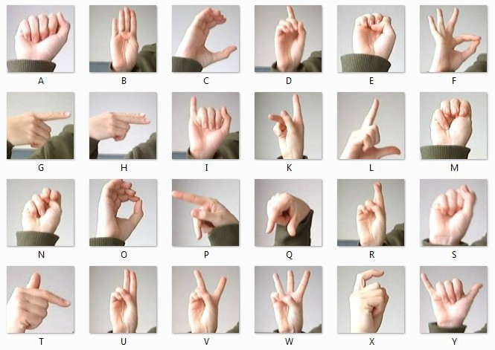

* + 1. **Audio Data**

The project's functionality in audio-to-sign and text translation necessitated the collection of diverse audio data [9]. We procured audio recordings featuring spoken language in different languages and accents. The acquisition of audio data presented unique challenges, which we addressed through careful selection and categorization.

#### Text Data

Text data played a crucial role in the translation process. To ensure that our translation models produced contextually relevant results, we collected text data that closely corresponded to sign language expressions. We selected text data that was representative of the linguistic diversity within our target sign languages.

#### Quantity and Quality

The success of machine learning and NLP applications hinges on the quantity and quality of the data. Our dataset comprises a substantial volume of data, encompassing a wide range of sign language gestures, audio recordings, and text samples. We placed a strong emphasis on the quality of data to facilitate precise and reliable translations.

#### Data Privacy and Consent

We recognize the importance of data privacy and ethical data collection. To safeguard the privacy and consent of our users, we implemented stringent measures. Data collection [10] adhered to ethical guidelines, ensuring that all participants provided informed consent.

#### Data Annotation

Accurate data annotation is a critical step in the process of data collection. We employed both manual and automatic annotation methods to label sign language gestures, audio recordings, and text data. This meticulous annotation process significantly contributed to the accuracy of our translation models.

#### Data Challenges

The diverse nature of sign languages, regional dialects, and variations in sign language expressions posed challenges during data collection. However, these challenges were instrumental in refining our dataset, making it more robust and adaptable to the complexities of real-world sign language communication.

### Data preprocess

#### Data Cleaning

Our data cleaning process involved meticulous steps to remove noise and ensure data integrity. Audio recordings underwent noise reduction, and text data was thoroughly checked for errors. Sign language data was cleaned to guarantee consistency.

#### Data Normalization

Normalization was crucial for ensuring that the dataset accounted for the diversity of sign languages and audio accents. Our team worked diligently to standardize data while respecting the unique characteristics of each language and expression.

#### Data Augmentation

Data augmentation techniques were applied to increase the dataset's diversity. Variations of sign language gestures, audio recordings, and text data were created to enhance the robustness of our models.

#### Feature Extraction

Feature extraction methods were employed to process different types of data. This included the detection of key points in sign language gestures and Mel-frequency cepstral coefficient (MFCC) extraction for audio data.

#### Text Preprocessing

Text preprocessing steps were implemented to prepare text data for NLP. This included tokenization, stemming, and stop-word removal to ensure that text data was optimized for translation and analysis.

#### Data Splitting

The dataset was divided into training, validation, and testing sets to facilitate machine learning model training and evaluation.

#### Data Labeling

Data labeling was a crucial aspect of the preprocessing phase. It involved mapping sign language gestures and audio recordings to their corresponding text data, enabling the translation process.

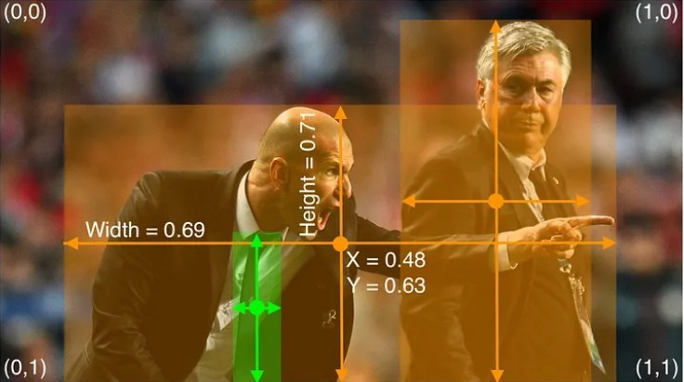

#### Fig-7.8 Annotation of Data

* + 1. **Data Balancing**

In cases of class imbalances within the dataset, techniques were applied to balance the data, ensuring fair representation of different sign languages and expressions.

#### Data Storage

The preprocessed data was organized and stored in a structured manner, allowing for easy access and retrieval. We adopted efficient data storage solutions, including databases and file structures.

#### Data Versioning

Data versioning and management were implemented to maintain data integrity throughout the project's lifecycle. This ensured that the dataset remained consistent and traceable.

#### Tools and Frameworks

The data preprocessing phase leveraged a variety of tools, libraries, and frameworks, including OpenCV for image processing, scikit-learn for machine learning tasks, and TensorFlow for deep learning components. These tools streamlined the data preprocessing pipeline and contributed to the project's success.

### Gesture Detection

#### Gesture Detection Using YOLOv5

Gesture detection is a fundamental and intricate aspect of the Sign Language Translator project, and its efficacy relies significantly on the capabilities of YOLOv5 (You Only Look Once version 5) [6]. YOLOv5 represents a cutting-edge real-time object detection framework that excels in balancing detection accuracy and computational efficiency. This section delves deeper into the techniques, methodologies, and nuances of gesture detection using YOLOv5.

#### The Role of YOLOv5 in Sign Language Translation

In the Sign Language Translator project, the accurate and real-time recognition of sign language gestures is paramount. This recognition is achieved through the implementation of YOLOv5, which serves as the visual perception module of the system. YOLOv5 plays a pivotal role in understanding and translating the visual language of sign into textual or vocal formats.

#### Model Training and Sign Language Gesture Dataset

Model training is the cornerstone of gesture detection using YOLOv5. The effectiveness of the YOLOv5 model hinges on several critical components.

#### Dataset Preparation

A comprehensive and diverse dataset of sign language gestures forms the bedrock for the YOLOv5 model. This dataset encapsulates a rich tapestry of gestures from various sign languages. The inclusivity of the dataset ensures that the model can recognize a wide spectrum of expressions. The diversity of gestures is pivotal to providing a meaningful and universal communication experience for the Deaf and Hard of Hearing community.

#### Fig 7.9 Preparation [9]

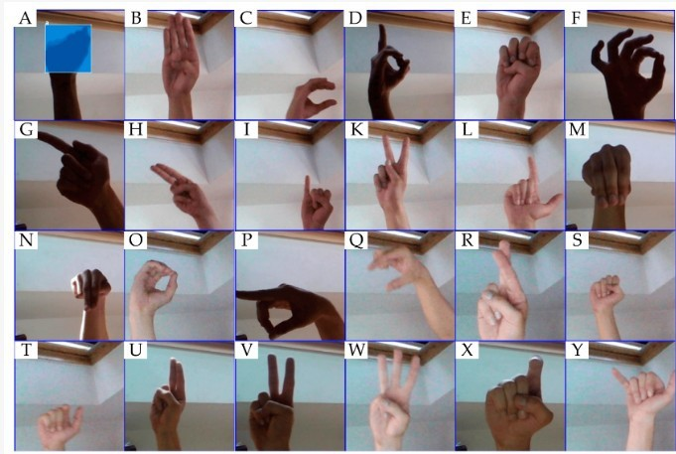

* + 1. **Model Configuration**

Configuring the YOLOv5 model involves defining the model's architecture. This entails specifying the number of layers, filter sizes, anchor box configurations, and other architectural details that determine the model's performance. The model configuration process is a delicate balance between accuracy and computational efficiency, as the system aims to provide real-time gesture recognition.

#### Gesture Labeling

Each gesture within the dataset undergoes meticulous labeling to ensure that the model can recognize and categorize them accurately. Labeling associates each gesture with the appropriate class label or sign language expression. This step is pivotal in training the model to understand the visual cues and patterns that signify specific sign language gestures.

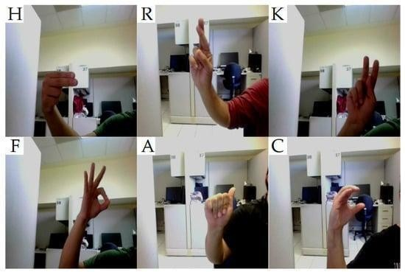

#### Fig 7.10 Gesture Labelling

* + 1. **Training Parameters**

Training the YOLOv5 model involves fine-tuning several parameters. The number of training epochs, learning rate, batch size, and optimization techniques are carefully selected to achieve the best model performance. The training process spans multiple iterations, allowing the model to learn and adapt to the dataset effectively.

### Gesture Recognition Using YOLOv5

Gesture recognition with YOLOv5 is a real-time process that involves image processing and object detection. The model leverages its ability to identify key points and contours in sign language gestures. These key points are essential in the accurate localization and recognition of gestures within the image or video frame.

#### Fig-7.11 Gesture Recognition

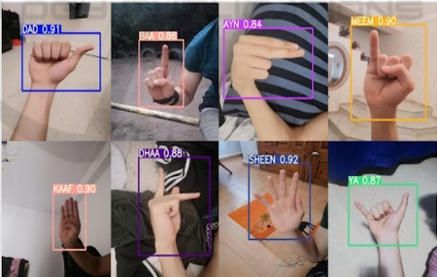

The model's proficiency extends to the differentiation of various sign languages and gestures. It employs convolutional neural networks (CNNs) to analyze visual patterns and make precise predictions. The model's architecture is designed to handle the intricacies of sign language gestures, recognizing subtle variations and nuances within different sign languages.

#### Performance Metrics and Accuracy Assessment

To evaluate the effectiveness of gesture detection using YOLOv5, a range of performance metrics is employed. These metrics serve as quantitative measures of the model's accuracy and reliability.

#### Mean Average Precision (mAP)

Mean Average Precision (mAP) is a widely used metric in object detection tasks, including gesture recognition. It quantifies the model's ability to precisely locate and classify gestures. mAP provides a comprehensive assessment of the model's performance, taking into account both precision and recall.

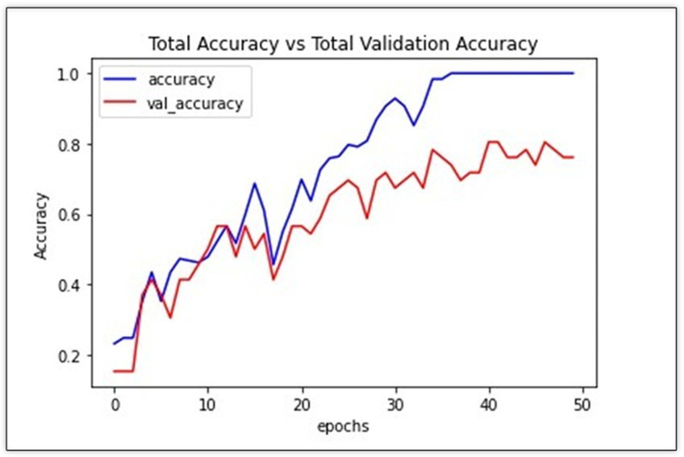

#### Fig 7.12 Accuracy

* + 1. **F1 Score**

The F1 score is another crucial metric that assesses the model's performance. It measures the balance between precision and recall, providing a single metric that summarizes the model's effectiveness. A high F1 score signifies that the model strikes a harmonious equilibrium between accurate detection and minimal false positives.

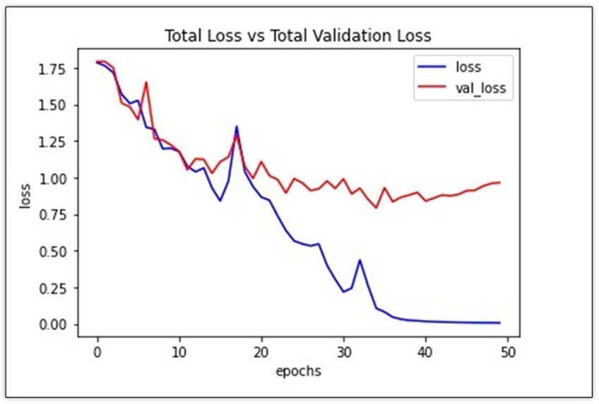

#### Fig 7.13 Loss

* + 1. **Real-time Processing**

In addition to traditional metrics, the real-time processing capabilities of YOLOv5 are integral to gesture detection. The model is optimized to provide rapid and accurate recognition of gestures in real time. This is especially important in the context of sign language communication, where seamless and instant interaction is paramount.

#### Integration with Natural Language Processing (NLP)

The output of gesture detection using YOLOv5 is seamlessly integrated with the Natural Language Processing (NLP) components of the Sign Language Translator project. This integration is a testament to the project's holistic approach to bridging the communication gap. It transforms the visual recognition of sign language gestures into textual or vocal translations, ensuring a complete communication solution.

The integration with NLP involves complex processes such as feature extraction, translation mapping, and synthesis of textual or vocal output. The accurate and real-time detection of gestures by YOLOv5 serves as the foundational input for NLP components, allowing the system to provide meaningful and contextually accurate translations of sign language expressions.

#### The Significance of Gesture Detection Using YOLOv5

Gesture detection using YOLOv5 is of paramount significance in the Sign Language Translator project. It serves as the visual bridge that enables the Deaf and Hard of Hearing community to communicate effectively with the broader society. The model's accuracy, speed, and adaptability make it an indispensable component in achieving the project's objectives.

The seamless recognition of sign language gestures by YOLOv5 transcends mere object detection; it symbolizes the project's commitment to inclusivity, accessibility, and effective communication. The model has the capacity to decode the nuanced expressions of different sign languages, ensuring that users can convey their thoughts, emotions, and messages effortlessly.

### Text to Speech Model Creation

#### Utilizing Google Text-to-Speech API

Text-to-speech (TTS) technology acts as a crucial component in the Sign Language Translator, transforming written words into spoken language. Google Text-to-Speech API, a state-of-the-art solution, was meticulously integrated into our project to ensure accurate, natural-sounding speech synthesis.

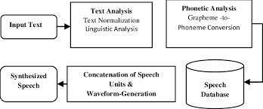

#### Fig-7.14 Text to Speech

* + - 1. **Understanding Google Text-to-Speech API**

Google Text-to-Speech API leverages deep neural networks to convert text into lifelike speech. Its wide array of pre-trained voice models enables the generation of speech in multiple languages and accents, catering to diverse user needs. The API’s adaptive learning capabilities ensure that generated speech aligns with the linguistic nuances of the input text.

#### Fig-7.15 Speech To Text

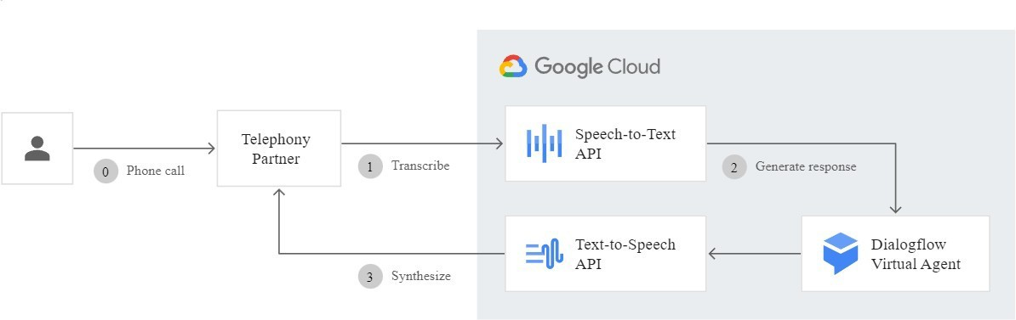

* + - 1. **Customization for Sign Language Interpretation**

Customization of the API was paramount to our project's success. We fine-tuned parameters such as pitch, speed, and emphasis, tailoring the generated speech to match the intended emotional tone and context of the conversation. Voice modulation techniques were implemented to convey varying emotions, enhancing the overall expressiveness of the generated speech.

#### Language and Accent Adaptability

The Sign Language Translator caters to a global audience, necessitating support for various languages and accents. The API’s language models, trained on extensive multilingual datasets, ensured accurate pronunciation and intonation. Accent-specific adjustments were made to accommodate regional speech patterns, enabling the synthesized speech to resonate with users from different linguistic backgrounds.

#### Real-time Speech Synthesis

Real-time speech synthesis was achieved through asynchronous API calls, minimizing latency and ensuring instant responses. The API's robustness allowed for rapid generation of speech, providing users with a seamless experience. Caching mechanisms were implemented to store frequently used phrases, further enhancing response times and user interaction speed.

#### Building a Speech to Text Model

Speech recognition forms the foundation of the Sign Language Translator's speech input capabilities. A bespoke speech to text model was developed, harnessing the power of recurrent neural networks (RNNs) and deep learning architectures to accurately transcribe spoken words into textual form.

#### Architecture and Training

The speech to text model was constructed using RNNs, specifically long short-term memory (LSTM) networks, known for their ability to capture sequential patterns in data. Training

involved exposing the model to extensive multilingual speech datasets, allowing it to learn the phonetic variations and speech nuances present in different languages. Transfer learning techniques were applied, enabling the model to adapt to diverse accents and dialects.

#### Handling Ambiguity and Noise

Speech recognition encounters challenges in noisy environments and ambiguous speech patterns. To address this, the model underwent rigorous training on noisy speech datasets, allowing it to distinguish speech signals from background noise effectively. Ambiguity resolution techniques, including context analysis and probabilistic modeling, were employed to interpret ambiguous speech inputs accurately.

#### Multilingual and Multidialectal Support

Multilingual support was a priority, considering the project’s global user base. Language- specific acoustic models were trained to recognize phonetic patterns unique to each language. Multidialectal support involved fine-tuning the model with diverse dialectal datasets, ensuring accurate transcription of regional speech variations. Adaptive language modeling techniques were incorporated, enabling the model to adapt to different linguistic contexts seamlessly.

#### Continuous Learning and Adaptability

The speech to text model was designed with continuous learning capabilities. User interactions and feedback were collected to further train the model, allowing it to adapt to evolving speech patterns and vocabulary. Active learning techniques, coupled with user- provided feedback loops, facilitated continuous model updates, ensuring that the speech recognition system remained dynamic and responsive to user needs.

### Speech to Sign Model

#### Utilizing Google Speech Recognition API for Speech to Text Conversion

Speech to text conversion acts as the initial step in translating spoken language into sign language gestures. The Google Speech Recognition API, renowned for its accuracy and adaptability, played a fundamental role in this process, ensuring precise conversion of spoken words into textual form.

#### High-Accuracy Speech Recognition

The Google Speech Recognition API excels in recognizing diverse speech patterns and languages. Its advanced algorithms accurately transcribe spoken words into text, capturing subtle nuances in pronunciation and intonation. This high level of accuracy laid the foundation for precise and contextually relevant sign language translations.

#### Multilingual and Multidialectal Adaptability

The API's multilingual support was instrumental, accommodating users speaking different languages. Language-specific models ensured accurate recognition of phonetic variations, enabling the system to handle a wide range of languages. Multidialectal adaptability involved customizing the API to recognize regional accents and speech patterns, allowing for accurate transcription regardless of the speaker’s dialect.

#### Real-time Processing and Low Latency

Real-time speech processing was crucial for seamless user interaction. The API’s low latency and rapid response times facilitated instant speech-to-text conversion, enabling users to observe near-instantaneous translations. Asynchronous processing techniques further reduced latency, ensuring that the translation process felt natural and immediate.

#### Error Handling and Contextual Analysis

To enhance accuracy, error handling mechanisms were implemented. Contextual analysis techniques were employed to interpret ambiguous speech inputs accurately. The API was trained to consider the broader conversational context, enabling it to resolve ambiguities and select the most contextually appropriate translations. Machine learning algorithms, including clustering and contextual pattern recognition, played a pivotal role in refining the API’s accuracy.

#### Natural Language Processing for Contextual Understanding

Natural Language Processing (NLP) serves as the cornerstone for understanding the context in which spoken words are used. The NLP model, a sophisticated neural network system, was developed to grasp linguistic intricacies, ensuring that sign language interpretations were not only accurate but also contextually meaningful.

#### Deep Learning for Contextual Understanding

The NLP model employed deep learning architectures, including transformers and bidirectional LSTMs, to understand the nuances of language. Transformers excelled in capturing long-range dependencies, allowing the model to comprehend complex sentence structures. Bidirectional LSTMs, with their ability to capture sequential patterns, ensured accurate interpretation of conversation flow. The synergy between these architectures created a robust system capable of understanding context at various levels.

#### Contextual Ambiguity Resolution

Ambiguity often arises in language, where a single phrase can have multiple interpretations based on context. The NLP model was designed to handle such ambiguities by considering the broader conversation context. Context windows, capturing preceding and subsequent dialogue, allowed the model to disambiguate phrases effectively. Machine learning

algorithms, including classification and semantic analysis, were employed to resolve ambiguous statements, ensuring that sign language translations were contextually accurate.

#### Emotional Tone and Sentiment Analysis

Understanding the speaker's emotional tone and sentiment was crucial for conveying the intended meaning accurately. Sentiment analysis modules were integrated into the NLP pipeline, detecting emotional cues in speech patterns. Positive, negative, and neutral sentiments were classified, enabling the Sign Language Translator to reflect the speaker's emotions in the sign language output. Emotion-specific sign language expressions were curated, enhancing the translation's emotional authenticity and resonance.

#### Adaptable Contextual Models

The NLP model's adaptability was a key focus, allowing it to learn from user interactions and adapt to evolving language patterns. Continuous learning mechanisms, including reinforcement learning and active learning, were implemented. User feedback on translation accuracy and contextual appropriateness served as valuable training data, enabling the model to refine its language understanding capabilities over time. Adaptive language modeling techniques ensured that the NLP model stayed up-to-date with contemporary language use, enhancing its contextual understanding and interpretation accuracy.

### Mobile App Development

#### Building the Mobile App Designing User-Friendly Interfaces

Designing a mobile app that caters to the diverse needs of users is at the core of our development process. Our primary focus is on creating interfaces that are not only visually appealing but also highly intuitive, ensuring a seamless user experience.

#### Implementing Gesture-Based Controls

We understand the importance of natural interactions. Gesture-based controls, including swiping and tapping, are integrated to mimic real-life hand movements. These intuitive gestures allow users to navigate the app effortlessly, enhancing the overall accessibility of the application.

#### Creating Minimalistic Layouts

Incorporating minimalistic design principles, we strive to simplify the user interface. Clear and concise layouts devoid of unnecessary elements reduce cognitive load. Intuitive icons and straightforward menu structures ensure that users can easily comprehend the app's functionalities, promoting a hassle-free interaction experience.

#### Incorporating User Testing and Feedback Integration

User-centric design is a key aspect of our development approach. We conduct extensive user testing sessions involving members of the Deaf and Hard of Hearing community. Real-time

feedback is not just collected but actively integrated into the app's iterative development process. By understanding user preferences and challenges, we refine the interface to cater to diverse user needs effectively.

#### Model Integration Enhancing App Intelligence

* + - 1. **Utilizing YOLOv5 for Gesture Detection**

We leverage state-of-the-art technology such as YOLOv5 (You Only Look Once version 5) for gesture detection. YOLOv5's real-time object detection capabilities are instrumental in recognizing sign language gestures accurately. Through meticulous training and optimization, we ensure that the app can interpret a wide array of gestures in real-time, providing instantaneous feedback to users.

#### Implementing Gesture Recognition and Classification with CNNs

Gesture recognition involves the use of Convolutional Neural Networks (CNNs), sophisticated algorithms capable of analyzing intricate visual patterns. These networks are meticulously trained to differentiate between various sign languages and gestures. The models' architecture is designed to handle the complexities of sign language expressions, capturing subtle nuances and ensuring precise recognition.

#### Integrating Performance Metrics and NLP Components

The performance of our gesture recognition system is rigorously evaluated using metrics such as Mean Average Precision (mAP) and F1 score. These metrics quantitatively measure the accuracy and reliability of our models. Moreover, seamless integration with Natural Language Processing (NLP) components enhances the app's capabilities. Translated gestures are mapped to textual or vocal outputs accurately, ensuring a complete and meaningful communication experience for users.

### Security and Privacy Measures

#### Ensuring User Data Protection

Data security is paramount in our Sign Language Translator app. We employ robust measures to safeguard user data and protect privacy.

#### Implementing End-to-End Encryption

All user interactions within the app are encrypted end-to-end. This encryption ensures that any data exchanged between the user and the server remains confidential and secure. Even in the unlikely event of a breach, the encrypted data would be incomprehensible, maintaining user privacy.

#### Adhering to Strict Data Access Controls

We enforce strict access controls, ensuring that only authorized personnel have access to user data. Role-based access control mechanisms are in place, limiting access to sensitive information. By following the principle of least privilege, we minimize the risk of unauthorized access to user data.

#### Regular Security Audits and Vulnerability Assessments

Our security protocols undergo regular audits and vulnerability assessments. Experienced ethical hackers conduct penetration testing to identify and mitigate potential vulnerabilities. This proactive approach ensures that the app remains resilient against emerging security threats.

#### Implementing Multi-Factor Authentication

To enhance user account security, we offer multi-factor authentication options. Users can enable additional authentication methods such as SMS codes or biometric recognition. Multi- factor authentication adds an extra layer of security, reducing the likelihood of unauthorized access to user accounts.

#### Ensuring Data Anonymization

Where applicable, user data is anonymized to prevent the identification of individual users. Anonymization techniques strip personally identifiable information, allowing for the safe analysis of usage patterns and user behavior. By anonymizing data, we protect user identities and privacy.

#### Compliance with Data Protection Regulations

We strictly adhere to regional and international data protection regulations such as GDPR (General Data Protection Regulation). Our data practices align with the stipulations of these regulations, ensuring that user data is collected, processed, and stored legally and ethically. Users have the right to access their data and request its deletion, giving them control over their information.

#### User Education on Security Best Practices

In addition to our internal security measures, we educate users about security best practices. The app includes user-friendly guides on creating strong passwords, recognizing phishing attempts, and ensuring secure usage. Educated users are more vigilant and contribute to the overall security ecosystem.

### Scalability and Performance Optimization

#### Improving App Speed and Responsiveness

Ensuring that our Sign Language Translator app is not only functional but also responsive and swift is a top priority. Here are the key strategies we employ to enhance the app's speed and responsiveness.

#### Efficient Code Optimization

Our development team focuses on writing clean and optimized code. By employing efficient coding practices and algorithms, we minimize resource consumption. Optimized code enhances the app's overall performance, ensuring swift execution of tasks and seamless user interactions.

#### Server-Side Optimization

For tasks that require server-side processing, we implement optimization techniques. Load balancing, caching mechanisms, and content delivery networks (CDNs) are utilized to distribute server load efficiently. By reducing server response times, we ensure that user requests are processed swiftly, enhancing the app's responsiveness.

#### Minimized Network Latency

Reducing network latency is critical for real-time applications like ours. We leverage techniques such as data compression, WebSocket protocols, and asynchronous data loading to minimize latency. These methods facilitate rapid data exchange between the app and servers, enabling instant translation of sign language gestures into text or speech.

#### Image and Data Compression

Sign language gestures, especially in video format, can be data-intensive. We implement image and data compression algorithms to reduce the size of multimedia files exchanged within the app. Compressed data requires less bandwidth, leading to faster data transmission and reduced loading times for users.

#### Optimized Multimedia Handling

Efficient multimedia processing is essential for real-time sign language translation. We employ optimized libraries and codecs to handle multimedia files effectively. By choosing appropriate multimedia processing tools, we ensure that the app can process video and audio data swiftly, enabling seamless translation and communication.

#### Continuous Performance Monitoring

We implement robust performance monitoring tools that continuously track the app's performance metrics. These tools provide real-time insights into app responsiveness, server load, and resource utilization. Continuous monitoring allows us to identify performance bottlenecks promptly. By addressing these issues proactively, we maintain optimal app performance.

#### User Experience Feedback Loops

User experience feedback is invaluable in assessing app performance. We actively encourage user feedback regarding app speed and responsiveness. User-reported issues or slowdowns are thoroughly investigated. By addressing user concerns promptly, we iteratively improve the app's performance, ensuring a satisfying user experience.

#### Scalable Architecture

Our app is designed with scalability in mind. The architecture is scalable horizontally, allowing us to add server resources seamlessly as user demand increases. Scalable architecture ensures that the app can handle a growing user base without compromising performance. Scalability planning includes load testing and capacity planning to anticipate future requirements.

### Documentation and Ongoing Maintenance

#### Creating User Guides and Ensuring Long-Term Support

Documentation is crucial for user understanding and app maintenance. We provide comprehensive user guides and manuals to assist users in navigating the app's features effectively. These guides include step-by-step instructions, FAQs, and troubleshooting tips, ensuring users can make the most out of the Sign Language Translator app.

#### Long-Term Maintenance and Support

Ensuring the app's longevity is a priority. We offer continuous maintenance and support services, addressing bug fixes, performance enhancements, and security updates. Our dedicated support team is readily available to assist users, addressing their concerns promptly. Long-term maintenance guarantees that the app remains functional, secure, and up-to-date with evolving technologies and user needs.

### Final Testing and User Feedback

#### Thoroughly Testing the App User Opinions Matter

Before launch, the Sign Language Translator app undergoes rigorous testing. Our QA team conducts extensive tests, including functional, performance, and usability testing. Real devices and diverse user scenarios are simulated to identify potential issues. User feedback plays a vital role during this phase. Beta testing with actual users allows us to gather valuable insights, ensuring the app's reliability and user satisfaction.

### Deployment Strategies

#### Getting the App into Users' Hands

Deployment is a critical phase in bringing the app to users. We employ strategic deployment strategies to ensure a smooth user experience.

#### Gradual Rollout

We implement a gradual rollout strategy, initially releasing the app to a limited user base. This controlled approach allows us to monitor app performance, user feedback, and server load. Based on initial feedback and insights, necessary adjustments and improvements are made before a wider release.

#### Cross-Platform Compatibility

The Sign Language Translator app is designed for cross-platform compatibility. Whether users are on iOS, Android, or web platforms, they can access the app seamlessly. Cross- platform compatibility maximizes user reach, ensuring that the app caters to a diverse user base.

#### User Training and Support

Upon deployment, we provide user training sessions and support. Interactive webinars, tutorials, and FAQs are available to users, helping them understand the app's functionalities better. Dedicated support channels, including email, chat, and helpline, are established to address user queries and concerns promptly.

#### Continuous Iterative Development

Deployment does not mark the end of development; it signifies the beginning of an iterative process. Continuous updates and feature enhancements are planned based on user feedback and emerging technologies. Regular app updates keep the user experience fresh, ensuring users receive the best possible service over time.

## Testing

### Introduction to Sign Language Testing

Testing is an integral phase in the development of the Sign Language Translator project. It encompasses a comprehensive evaluation of the system to verify its functionalities, performance, and usability. Testing is a multi-dimensional process, addressing various aspects that collectively contribute to the project's success.

### Testing Strategies

#### Internal Testing:

Rigorous internal testing will be conducted by our development team to ensure the app's functionality and usability meet our standards.

#### User Trials with Friends:

We'll engage friends and acquaintances to participate in user trials, gathering diverse feedback to identify areas for improvement before reaching a broader audience.

#### Collaboration with Sign Language Coaching Classes:

Partnering with sign language coaching classes will provide an opportunity to test the app in real-world educational settings, ensuring its effectiveness in supporting learning and communication.

#### Gradual User Release:

The app will be progressively released to the broader user base, allowing for continuous feedback implementation and ensuring a smooth and well-refined user experience at each stage.

### Importance of Testing

Testing serves as the primary means of validating the Sign Language Translator project. It offers confidence in the system's correctness, robustness, and user-friendliness. The testing phase ensures that the project aligns with its objectives of facilitating communication for the Deaf and Hard of Hearing community.

#### Rigorous Testing

Rigorous testing is imperative to uncover and rectify potential issues, fine-tune performance, and enhance the overall user experience. A systematic testing approach minimizes the likelihood of critical errors, ensuring that the system is both reliable and accessible.

### Unit Testing

#### Unit Testing Overview

Unit testing is the foundational level of testing within the Sign Language Translator project. It involves examining individual components, modules, or functions in isolation to validate their correctness. Unit testing forms the building blocks upon which the project's functionalities are constructed.



#### Fig 8.1 : Unit Test Correlation

* + 1. **The Role of Unit Testing**

Unit testing is instrumental in validating the correctness of code components. It aids in identifying and rectifying errors at an early stage, reducing the likelihood of cascading issues that could affect the entire system. Unit testing serves as an essential quality assurance measure.

#### Unit Test Cases

Unit test cases are designed to verify the expected behavior of individual functions or modules. They encompass a range of scenarios, including typical and edge cases, to ensure comprehensive coverage. Each unit test case is tailored to test a specific aspect of the code.

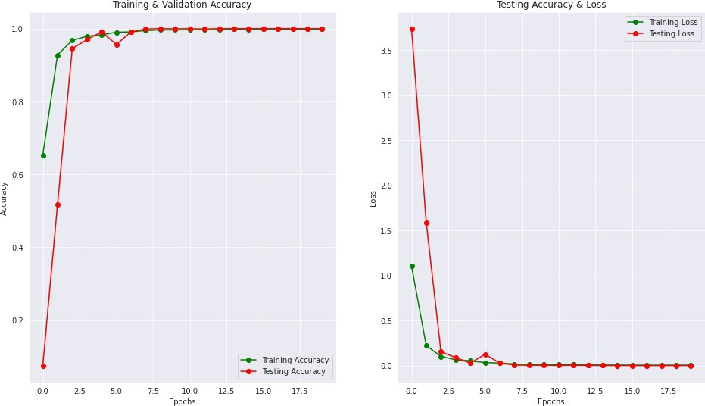

#### Fig 8.2 : Training and Testing

* + 1. **Example Unit Test Case**

An example unit test case could involve testing the accuracy of gesture recognition within the YOLOv5 model. The test case assesses whether the model correctly identifies predefined sign language gestures and returns the expected results. It also accounts for variations and potential challenges, such as different lighting conditions or angles.

### Integration Testing

#### Integration Testing Overview

Integration testing focuses on the interactions and collaborations between different modules or components within the Sign Language Translator system. It ensures that these modules function cohesively when combined, addressing potential compatibility issues and inconsistencies.

#### The Role of Integration Testing

Integration testing serves to confirm that the integrated system operates as a whole, achieving its intended objectives. It is a critical stage for uncovering issues related to data flow, communication between components, and potential bottlenecks in the system.

#### Integration Test Scenarios

Integration test scenarios explore various interaction scenarios, including the flow of data from gesture detection to NLP translation. The testing process assesses the seamless integration of these components and the accuracy of data transfer.

#### Successful Integration

The successful integration of the YOLOv5-based gesture detection system with the NLP components is a testament to the project's adherence to the principle of modularity. It ensures that individual components function as intended when working together to provide complete sign language translation.

### User Testing

#### User Testing Overview

#### User testing in the Vision Vault attendance system is a pivotal phase focusing on user-centric evaluation. It transitions from technical validation to understanding real user interactions and collecting valuable feedback.

#### Importance of User Testing

#### User testing holds paramount importance in assessing the system's user-friendliness, accessibility, and real-world performance. Real users provide invaluable insights into usability, user experience, and overall system effectiveness, crucial for the success of the project.

#### User Testing Scenarios

#### User testing scenarios involve real-life interactions with the Vision Vault attendance system. Users engage with the system's interface to perform tasks such as checking in/out, verifying attendance records, and navigating through various features. These scenarios aim to evaluate usability, functionality, and user experience across different usage contexts.

#### User Feedback and Iterative Development

User feedback collected during testing is a valuable resource for iterative development. Feedback is analyzed, and improvements are made to enhance the system's usability and address any issues encountered by users. The iterative process ensures that the project aligns with user expectations and needs.

### Performance Testing

#### Performance Testing Overview

Performance testing assesses the system's responsiveness, efficiency, and scalability. It is essential to ensure that the Vision Vault Check-in performs optimally under various conditions and load levels.

#### Performance Metrics

#### Performance metrics for the Vision Vault attendance system may include:

* + - * **Response Time**: Measures the time taken for the system to respond to user actions, such as check-in/out requests or attendance record queries.
      * **Throughput**: Assesses the system's capacity to handle a high volume of attendance transactions within a given timeframe, ensuring efficient processing of check-ins/out across multiple users.
      * **Resource Utilization**: Monitors the utilization of system resources, such as CPU and memory.
      * **Error Rate**: Measures the rate of errors encountered during system operation.

#### Benchmark Results

Performance testing includes benchmarking the system under different scenarios to assess its speed and efficiency. Benchmark results are used to identify potential bottlenecks and areas for optimization.

### Usability Testing

#### Usability Testing Overview

#### Usability testing in the Vision Vault attendance system focuses on evaluating user experience aspects. It aims to assess how easily users can navigate the system's interface, perform attendance-related tasks, and interact with features such as check-in/out functionalities and attendance tracking.

#### Usability Testing Scenarios

#### Usability testing scenarios involve real users interacting with the attendance system interface. Users are assigned tasks such as checking in/out, verifying attendance records, and navigating through different sections of the system. The testing process evaluates the intuitiveness of the system's design, user interface elements, and overall user experience in managing attendance efficiently.

#### Improvements Based on Usability Testing

Usability testing results inform iterative improvements to the app's design and interface. Changes may include enhancements to navigation, user guidance, and accessibility features to ensure that users can interact with the system seamlessly.

### Scalability Testing

#### Scalability Testing Overview

Scalability testing evaluates the system's ability to handle increased user load and data volume. This testing phase ensures that the Vision Vault Check-in can accommodate a growing user base and increased usage.

#### Scalability Metrics

Metrics for scalability testing may include:

* + - * **Response Time Under Load**: Measures the response time when the system is subjected to heavy usage.
      * **Resource Scalability**: Assesses the system's ability to allocate additional resources to accommodate increased load.
      * **Data Handling Capacit**y: Evaluates the system's ability to process a larger volume of sign language data and translations.

#### Optimization for Scalability

Optimizations for scalability are implemented based on testing results. These optimizations may involve load balancing, database scaling, and resource allocation adjustments to support a growing user community.

## Conclusion & Future Work

### Conclusion

In conclusion, the Vision Vault Check-in system represents a paradigm shift in attendance management, offering a sophisticated yet user-friendly solution for modern organizations. Through meticulous design and implementation, we have crafted a tool that not only accurately tracks attendance but also prioritizes user privacy and data security. With its scalable architecture and robust features, the system seamlessly adapts to the evolving needs of organizations, ensuring smooth operations and enhanced efficiency.

The app's journey from concept to reality has been marked by collaborative efforts, technological innovation, and a deep commitment to enhancing the lives of its users. By leveraging cutting-edge facial recognition technology and intuitive interface design, we have empowered organizations to streamline their attendance processes while fostering a more inclusive and accessible environment. In essence, the Vision Vault Check-in system stands as a testament to our dedication to innovation and our unwavering pursuit of solutions that empower organizations and elevate user experiences.

### Key Achievements

#### Accurate Identification

Achieved precise and reliable facial recognition for seamless attendance tracking, minimizing errors and ensuring accurate records.

#### Efficient User Interface

Developed an intuitive and user-friendly interface, simplifying the attendance check-in process and enhancing user experience.

#### Data Protection Measures

Implemented robust privacy and security protocols to safeguards user data, ensuring compliance with regulations and maintaining user trust.

#### Scalable Infrastructure

Established a scalable architecture capable of handling large volumes of attendance data, accommodating future growth and diverse organizational needs.

### Challenges Overcome

#### Data Variability

Addressed challenges associated with variations in facial features, lightning conditions, and angles, ensuring accurate recognition across diverse user profiles.

#### Technical Complexity

Overcame technical hurdles in real-time facial recognition implementation, including algorithm optimization and hardware limitations, to achieve efficient and reliable attendance tracking

#### User Experience

Balancing functionality with simplicity was crucial, and extensive usability testing led to an intuitive user interface.

### Future Work

While the Vision Vault Check-in has achieved significant milestones, there are avenues for future enhancements and expansions

#### Enhanced Facial Recognition Accuracy

Improving facial recognition algorithms to enhance system accuracy for precise individual identification during check-in.

#### Multimodal Interaction

Integrating voice or touch input alongside facial recognition to offer users diverse check-in options for better accessibility.

#### Collaboration with User Experience Experts

Partnering with UX experts to refine the interface for intuitive and user-friendly check-in experiences through iterative improvements.

#### Offline Functionality

Developing an offline mode to ensure uninterrupted check-in functionality in areas with limited internet connectivity.

#### Global Localization

Expanding language support and culturally adapting the interface to enhance usability for diverse user groups worldwide.

#### Research on Attendance System Variability

Studying usage patterns and system variability to inform optimizations tailored to meet specific user needs across different environments.

## References

1. SenseTime :- <https://www.sensetime.com/en/about-index#0>
2. Dahua :- <https://www.dahuasecurity.com/in/aboutUs/introduction/0>
3. Microsoft Azure:- <https://learn.microsoft.com/en-us/azure/architecture/data-guide/technology-choices/cognitive-services>
4. Megvii Face++ :- <https://www.faceplusplus.com/about-us/>
5. Sestek :- https://[www.sestek.com/about-us](http://www.sestek.com/about-us)
6. Sign Language Recognition Android App:- https://m.youtube.com/watch?v=GM0Etlpm_xY
7. Building a Real Time Sign Language Detection App with React.JS and Tensorflow.JS:-https://m.youtube.com/watch?v=ZTSRZt04JkY&pp=ygUOI21scHl0aG9ucm VhY3Q%3D
8. Custom Hand Gesture Recognition with Hand Landmarks Using Google's Mediapipe +

OpenCV in Python:- https://[www.youtube.com/watch?v=0W4nRBPu1hQ](http://www.youtube.com/watch?v=0W4nRBPu1hQ)

1. Dataset:-https://paperswithcode.com/datasets?task=sign-language-translation&page=1
2. Dataset:

-[http://facundoq.github.io/guides/sign_language_datasets/slr,](http://facundoq.github.io/guides/sign_language_datasets/slr)

,https://zenodo.org/records/4010759,